Assignment 1:Biomedical.

Problem number one:

1-the derivative:

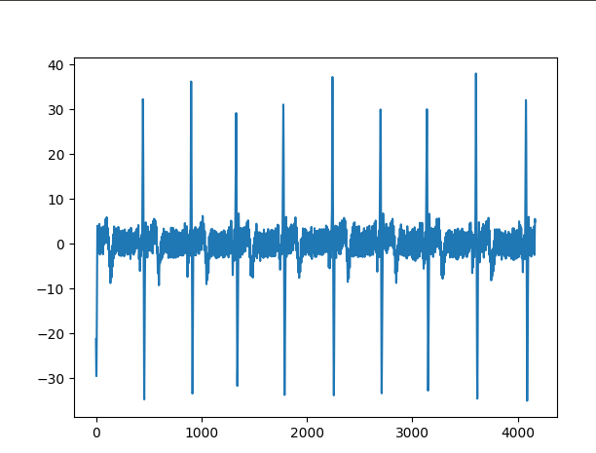

2-Squaring:

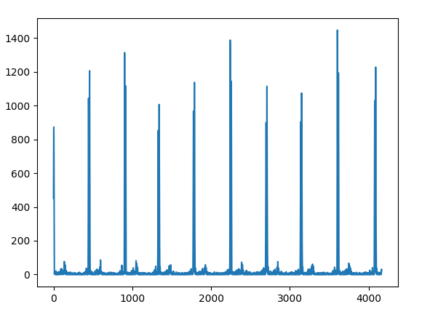

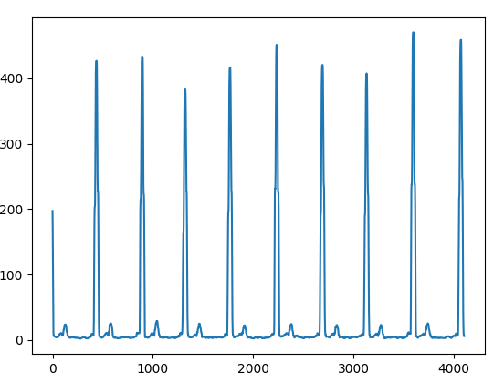3-smoothing:

4-Autocorrelation:

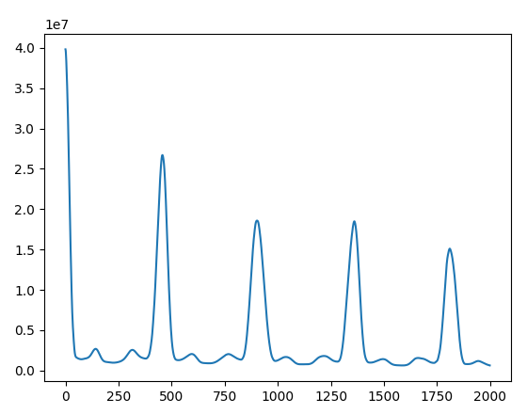

5-Heart rate:

60/(457.5/512)=67

problem no 2

1-autocorr 2

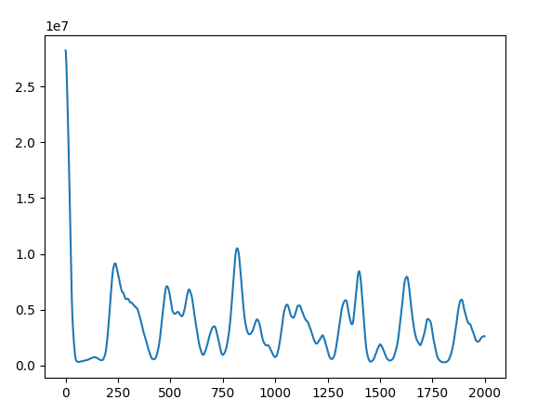

2-Heart rate isn’t regular and is more rapid than the normal reading in the previous example, as the peaks in this example are irregular and more close to each others.

3-The suggested measure is to calculate the values above the mean values of the autocorrelation , as it will indicate the presence of peaks, and compare it to that of the normal ECG.

4-code:

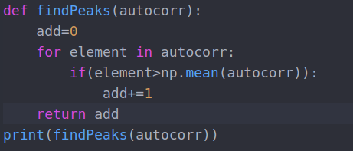

5-the value in example 1 is:415

the value in example 2 is:876